 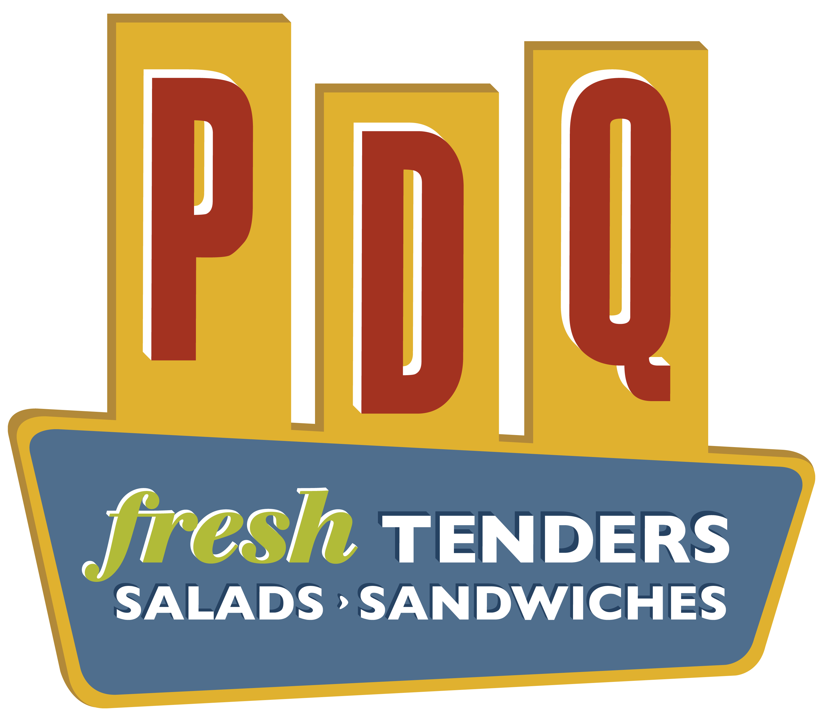

Dear Lutz Prep & Pre-Prep Families,

Lutz Prep has partnered with PDQ to enhance the education of our LP students. PDQ has allotted Lutz Prep a limited number of $10 gift cards that are available for purchase for only $7. We are pleased to sell these cards at a 30% discount to our Lutz Prep families & friends as a perk. These cards are good at all PDQ locations and do not expire!

Sale will last until the inventory of cards is depleted. All proceeds raised from the sale of these gift cards will go directly back to our school for programs that benefit our children.

It's simple:

1. Complete the form below detailing the amount of cards requested and amount paid.

2. Attach payment to this form.

3. Return to your homeroom teacher.

If you have any questions, please feel free to contact Emily Kaim at [businessmanager@lutzprep.org](mailto:businessmanager@lutzprep.org).

---------------------------------------------------------------------------------

Parents Name:

Student’s Name:

Student’s Grade & Teacher:

# of $10 Gift Cards Requested:

Amount Enclosed: # of Gift Cards x $7 =